Grade 3 Homework 10th November, 2013

In addition to these tasks there will be additional weekly maths homelinks sent with your child to complete.
Please complete and hand in your homework book on Thursday Thank you for supporting your child.
Sunday  Reading, Spelling, Math Facts,  Writing  Write a sentence for each of your ten spelling words. Show that you understand what the words mean.  Remember to begin every sentence with a capital letter, end with a full stop, question or exclamation mark, and underline the spelling word using a ruler and a coloured crayon. | Monday  Reading, Spelling, Math Facts,  Math’s - Estimating and measuring  Choose an object to measure. First estimate its length, then measure the object in inches and centimetres. Remember to measure to the nearest whole number, half or quarter.  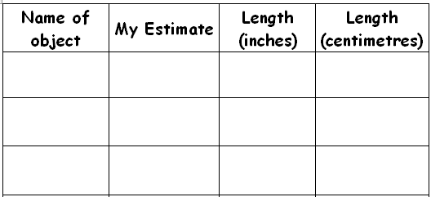
Tuesday  Reading, Spelling, Math Facts,  Writing  This week we are looking at the correct use of speech marks, exclamation marks and using different words for ‘said’. Please put the following phrases into sentences, using speech marks, exclamation marks and use different words for said.  E.g. I don’t want to go to bed!  “I don’t want to go to bed!” shouted Fred loudly.  - I’m tired!  - I had some ice cream for breakfast!  - Let’s have a race! 4) It’s spooky in here! | Wednesday  Reading, Spelling, Math Facts,  Remember the tests tomorrow!  Unit of Inquiry  Advertisements - The five essential elements  headline, logo, slogan, image, copy  Find an advert and stick it in your homework book. The advert needs to be a good example showing the five essential elements. Identify the elements using arrows and headings and write 5 sentences explaining what these words mean
Spelling try sheet – 10th November, 2013

Practice your spelling words every day. Follow the pattern – look, cover, write, check. If you get a word wrong try the pattern again.

 | Sunday | Monday | Tuesday | Wednesday | Thursday – Test
* read
* meal
* deal
* team
* dream
cream
beach
clean
really
teaspoon

* ‘no excuse words’ = must know how to spell them

