Grade 3 Homework 15th September, 2013

In addition to these tasks there will be additional weekly maths homelinks sent with your child to complete.
Please complete and hand in your homework book on Thursday Thank you for supporting your child.
Sunday  Reading, Spelling, Math Facts,  Writing  Write a sentence for each of your ten spelling words. Show that you understand what the words mean.  Remember to begin every sentence with a capital letter, end with a full stop, question or exclamation mark, and underline the spelling word using a ruler and a coloured crayon. | Monday  Reading, Spelling, Math Facts,  Math’s  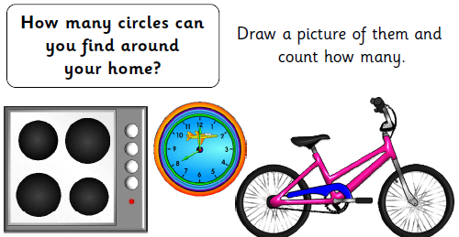
Tuesday  Reading, Spelling, Math Facts,  Writing  Character Profile  Be an author: Choose a character from a story that you have read this week. Write a description about them.  Remember that what a character says and does tells you what they are like.  Be an illustrator: Draw a picture to match your character profile writing. | Wednesday  Reading, Spelling, Math Facts,  Remember the tests tomorrow!  Unit of Inquiry  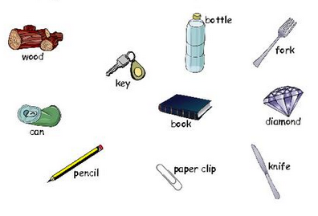  Test lots of objects  and find out if they  are MAGNETIC or  NON-MAGNETIC.  Make 2 lists and  draw pictures of  what you discover.
Spelling try sheet – 15th September, 2013

Practice your spelling words every day. Follow the pattern – look, cover, write, check. If you get a word wrong try the pattern again.

 | Sunday | Monday | Tuesday | Wednesday | Thursday – Test
lesson
spelling
napkin
collar
traffic
suggest
puppet
falcon
hello
dancer

