Grade 3 Homework 17th November, 2013

In addition to these tasks there will be additional weekly maths homelinks sent with your child to complete.
Please complete and hand in your homework book on Thursday Thank you for supporting your child.
Sunday  Reading, Spelling, Math Facts,  Writing  Write a sentence for each of your ten spelling words. Show that you understand what the words mean.  Remember to begin every sentence with a capital letter, end with a full stop, question or exclamation mark, and underline the spelling word using a ruler and a coloured crayon. | Monday  Reading, Spelling, Math Facts,  Math’s – Finding the Perimeter  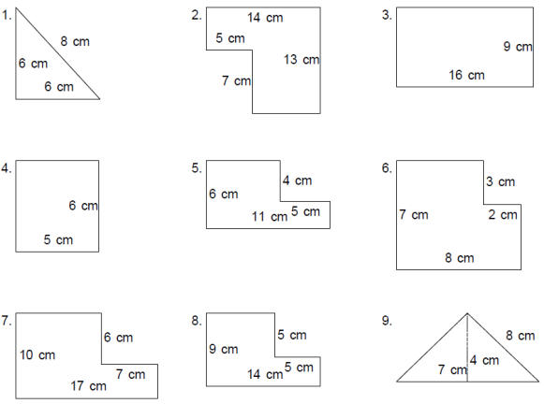  Click on this link and  draw the shapes in your  homework book.  Calculate the perimeter  for each shape.
Tuesday  Reading, Spelling, Math Facts,  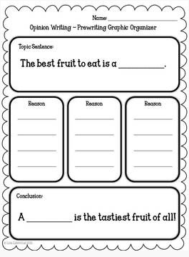  Writing  Opinion writing –  Give your opinion on your  favourite fruit.  Remember to include  3 reasons to explain  your thinking. | Wednesday  Reading, Spelling, Math Facts,  Remember the tests tomorrow!  Unit of Inquiry  Make a poster to advertise a  42nd Spirit of the Union party!  Make an attractive and informative poster that will capture the attention of your readers. Use effective titles that are short and memorable, pictures and words that make your poster bright, colourful and grab your reader’s attention… and don’t forget to include all the essential information in the copy!
Spelling try sheet – 17th November, 2013
Practice your spelling words every day. Follow the pattern – look, cover, write, check. If you get a word wrong try the pattern again.

 | Sunday | Monday | Tuesday | Wednesday | Thursday – Test
high
every
near
add
food
* best
* next
else
* check
* grand
* stand
chocolate
choose
