Grade 3 Homework 20th October, 2013

In addition to these tasks there will be additional weekly maths homelinks sent with your child to complete.
Sunday  Reading, Spelling, Math Facts,  Writing  Write a sentence for each of your ten spelling words. Show that you understand what the words mean.  Remember to begin every sentence with a capital letter, end with a full stop, question or exclamation mark, and underline the spelling word using a ruler and a coloured crayon. | Monday  Reading, Spelling, Math Facts,  Math’s  Number stories  Janaa's favorite games at the festival were the miniature rifle range and the bouncy castle. Janaa tries the miniature rifle range 25 times and the bouncy castle 12 times. In all, how many times does Janaa play the games?  Answer: ________________________________________  Number model:____________________________________  How do you know your answer makes sense?  ________________________________________________  Make up some of your own number stories.  using addition and subtraction operations
Tuesday  Reading, Spelling, Math Facts,  Writing  Be an author: Choose a story that you  have read this week.  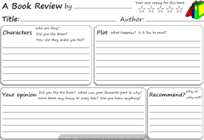  Write a book review about your chosen story and recommend it to a friend, saying what you think they would enjoy about this story.  Be an illustrator: Draw a picture to go with your book review. | Wednesday  Reading, Spelling, Math Facts,  Remember the tests tomorrow!  Unit of Inquiry  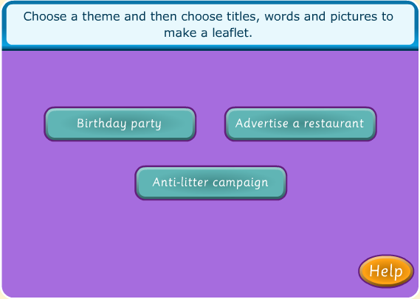  Play this game to design an  advert for a restaurant.  Next choose your own favourite  place to eat and design an  advert to recommend it to  other people.  Remember to include:  Title, picture, writing, slogan
Please complete and hand in your homework book on Thursday Thank you for supporting your child.
Spelling try sheet – 20th October, 2013

Practice your spelling words every day. Follow the pattern – look, cover, write, check. If you get a word wrong try the pattern again.

 | Sunday | Monday | Tuesday | Wednesday | Thursday – Test
* slower
* slowest
* harder
* hardest
* lighter
lightest
prettier
prettiest
scarier
scariest

* ‘no excuse words’ = must know how to spell them

