Grade 3 Homework 22nd September, 2013

In addition to these tasks there will be additional weekly maths homelinks sent with your child to complete.
Please complete and hand in your homework book on Thursday Thank you for supporting your child.
Sunday  Reading, Spelling, Math Facts,  Writing  Write a sentence for each of your ten spelling words. Show that you understand what the words mean.  Remember to begin every sentence with a capital letter, end with a full stop, question or exclamation mark, and underline the spelling word using a ruler and a coloured crayon. | Monday  Reading, Spelling, Math Facts,  Math’s  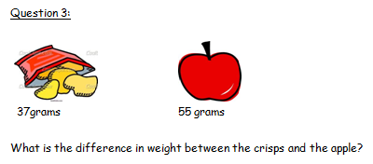  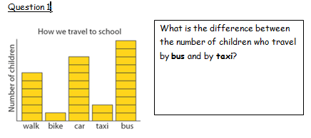  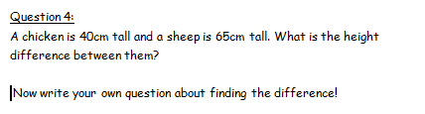  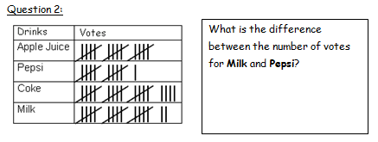
Tuesday  Reading, Spelling, Math Facts,  Writing  Be an author: Choose a story that you have read this week. Write a description of the setting for your chosen story. Remember that the setting is where and when the story takes place.  Remember to describe lots of details. Use adjectives and similes to help.  Be an illustrator: Draw a picture of the setting for your chosen story. | Wednesday  Reading, Spelling, Math Facts,  Remember the tests tomorrow!  Unit of Inquiry  http://www.bbc.co.uk/schools/scienceclips/ages/7_8/magnets_springs_fs.shtml  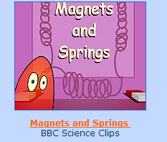  Follow the link above to  play a great game on  Magnetism and Springs.  Write a few sentences  about what you know  about magnetism in  your homework book.
Spelling try sheet – 22nd September, 2013

Practice your spelling words every day. Follow the pattern – look, cover, write, check. If you get a word wrong try the pattern again.

 | Sunday | Monday | Tuesday | Wednesday | Thursday – Test
pennies
inches
plants
families
bodies
glasses
wishes
pockets
lists
copies

