Grade 3 Homework 29th September, 2013

In addition to these tasks there will be additional weekly maths homelinks sent with your child to complete.
Please complete and hand in your homework book on Thursday Thank you for supporting your child.
Sunday  Reading, Spelling, Math Facts,  Writing  Write a sentence for each of your ten spelling words. Show that you understand what the words mean.  Remember to begin every sentence with a capital letter, end with a full stop, question or exclamation mark, and underline the spelling word using a ruler and a coloured crayon. | Monday  Reading, Spelling, Math Facts,  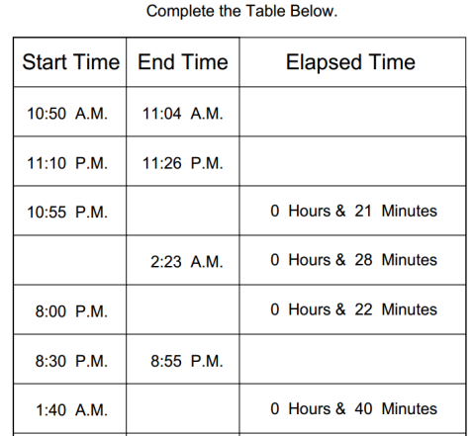  Math’s  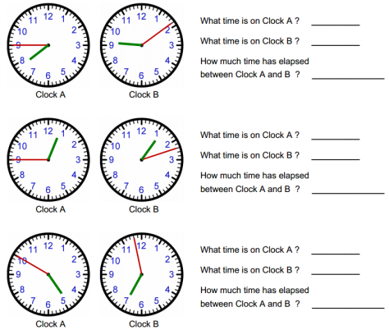
Tuesday  Reading, Spelling, Math Facts,  Writing  Be an author: Choose a story that you have read this week. Write a description of the theme for your chosen story. Remember that the theme is plot of the story. What problem happens and how is it resolved?  Remember to describe lots of details. Use adjectives and similes to help.  Be an illustrator: Draw a picture of your favourite part of the story. | Wednesday  Reading, Spelling, Math Facts,  Remember the tests tomorrow!  Unit of Inquiry  https://www.youtube.com/watch?v=fWzIfz5SKZQ  The children in Grace's class say that she can't be Peter Pan but her Ma and Nana tell her that she can be anything she wants if she “puts her mind to it”. What does this mean?  Who shows empathy to Grace in the story and how?  How does Grace show tolerance?
Spelling try sheet – 29th September, 2013

Practice your spelling words every day. Follow the pattern – look, cover, write, check. If you get a word wrong try the pattern again.

 | Sunday | Monday | Tuesday | Wednesday | Thursday – Test
*books
*pencils
*bunches
*crashes
*parties
watches
quarters
supplies
libraries
mysteries

* ‘no excuse words’ = must know how to spell them

